Upshift/Downshift Indicator RTT – CGEA1.3 B479 Specific

Functional Description

This functional specification is specific to the B479 program. The logic contained within does not support a vehicle with SDM. If SDM is added to the program, a new version of this spec must be released that removes the logic for the EcoMode RTT and the SelDrvMdeDsply_B_Avail Signal because both are part of the SDM feature.

The purpose of the Upshift/Downshift Indicator RTT is to inform the driver that a gear shift needs to be made for fuel efficient operation of a manual transmission powertrain. Traditionally it has been required on certain programs in North America to help achieve higher CAFÉ numbers. Per EU regulation 661/2009/EC, however, for homologation application dates after 1 Nov 2012 homologations, and registrations after 1 Nov 2014, the upshift indicator is now required for EU applications as part of greenhouse gas regulation. Per EU regulation the Upshift Indicator shall also function for automatic transmission applications when in select shift mode. It is recommended this feature be disabled where not required per regulation or as required per powertrain to help CAFÉ numbers in order to prevent TGW. This telltale has been shown to generate between 1 – 2 TGW in North American Markets.

The Upshift_RTT correlates the TrnManShif_D_IndDrv signal and the Operational_Mode to activate or deactivate the Upshift RTT. The Downshift_RTT correlates the TrnManShif_D_IndDrv signal and the Operational_Mode to activate or deactivate the Down Shift RTT. The Gear_Indication correlates the module configuration, the TrnManShif_D_IndDrv and TrnManShifGear_D_IndDrv signals and the Operational_Mode to activate or deactivate the Gear_Indication. The Gear_Indication is only intended for vehicles with Manual Transmissions.

The Upshift_RTT shall provide an iconic representation that will illuminate or extinguish to inform the driver of a possibility that the Upshift indicator is on.

The Upshift Indicator shall be implemented in a Fixed/Dedicated RTT to ensure regulation is met.

When EcoMode or EcoMode Comfort is Active, the Upshift and Downshift RTT will be filled in (solid arrow) to make the shift indicator more visible. When the EcoMode RTT shares the same location with the Upshift and Downshift RTT’s and EcoMode or EcoMode Comfort is Active and the Upshift and Downshift RTT’s are not Active, the EcoMode RTT will be Active. When the EcoMode RTT has a dedicated location and EcoMode or EcoMode Comfort is Active, the EcoMode RTT will be Active.

Interfaces

Interface Context Diagram (I/O Block Diagram)
- 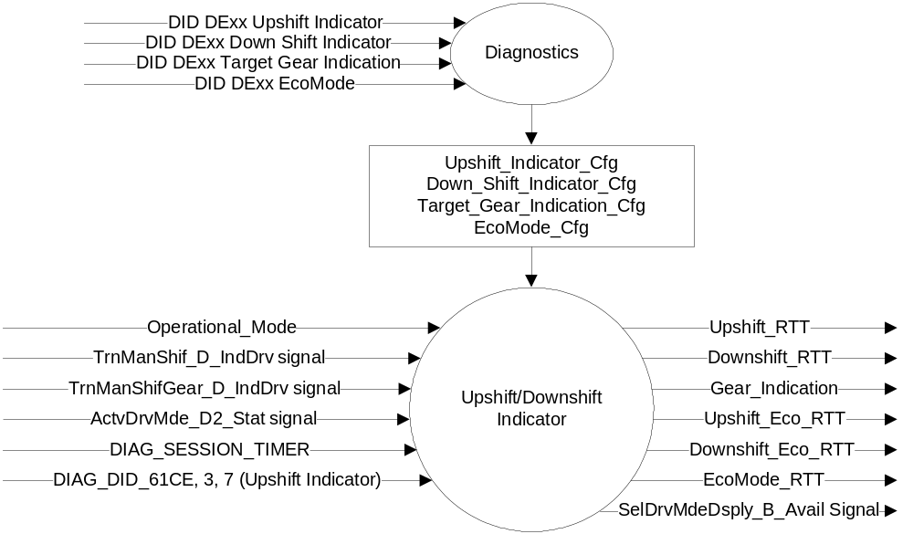Upshift/Down Shift/ Gear Indication

Inputs

      - INTERNAL:
            - DIAG_SESSION_TIMER
            - Operational_Mode
            - DIAG_DID_61CE, 3, 7 (Upshift Indicator)
            - Upshift_Indicator_Cfg
            - Down_Shift_Indicator_Cfg
            - Target_Gear_Indication_Cfg
            - EcoMode_Cfg
      - MUX message on the CAN Bus

- TrnManShif_D_IndDrv Signal
Signal Name | Size  (bits) | Detail | Units | Res | Offset | State Encoded | Min. | Max.
TrnManShif_D_IndDrv | 3 |  |  | 1 | 0 |  | 0 (0x0) | 7 (0x7)
 |  | No_indication |  |  |  | 0x0
 |  | Upshift_Fuel_Economy _recommendation |  |  |  | 0x1
 |  | Upshift_Performance_  recommendation |  |  |  | 0x2
 |  | Upshift_warning (fuel cut imminent and reaching rev limit) |  |  |  | 0x3
 |  | Downshift_recommendation |  |  |  | 0x4
 |  | Undefined |  |  |  | 0x5
 |  | Undefined |  |  |  | 0x6
 |  | Undefined |  |  |  | 0x7

- TrnManShifGear_D_IndDrv Signal
Signal Name | Size  (bits) | Detail | Units | Res | Offset | State Encoded | Min. | Max.
TrnManShifGear_D_IndDrv | 3 |  |  | 1 | 0 |  | 0 (0x0) | 7 (0x7)
 |  | No Indication |  |  |  | 0x0
 |  | Indicate gear 1 (1) |  |  |  | 0x1
 |  | Indicate gear 2 (2) |  |  |  | 0x2
 |  | Indicate gear 3 (3) |  |  |  | 0x3
 |  | Indicate gear 4 (4) |  |  |  | 0x4
 |  | Indicate gear 5 (5) |  |  |  | 0x5
 |  | Indicate gear 6 (6) |  |  |  | 0x6
 |  | Indicate Reversed Gear (R) |  |  |  | 0x7

- ActvDrvMde_D2_Stat Signal
Signal Name | Size  (bits) | Detail | Units | Res. | Offset | State  Encoded | Min | Max
ActvDrvMde_D2_Stat | 5 |  | SED | 1 | 0 |  | 0 (0x0) | 31 (0x1F)
 |  | SelDrvMde01 |  |  |  | 0x0
 |  | SelDrvMde02 |  |  |  | 0x1
 |  | SelDrvMde03 |  |  |  | 0x2
 |  | SelDrvMde04 |  |  |  | 0x3
 |  | SelDrvMde05 |  |  |  | 0x4
 |  | SelDrvMde06 |  |  |  | 0x5
 |  | SelDrvMde07 |  |  |  | 0x6
 |  | SelDrvMde08 |  |  |  | 0x7
 |  | SelDrvMde09 |  |  |  | 0x8
 |  | SelDrvMde10 |  |  |  | 0x9
 |  | SelDrvMde11 |  |  |  | 0xA
 |  | SelDrvMde12 |  |  |  | 0xB
 |  | SelDrvMde13 |  |  |  | 0xC
 |  | SelDrvMde14 |  |  |  | 0xD
 |  | SelDrvMde15 |  |  |  | 0xE
 |  | SelDrvMde16 |  |  |  | 0xF
 |  | SelDrvMde17 |  |  |  | 0x10
 |  | SelDrvMde18 |  |  |  | 0x11
 |  | SelDrvMde19 |  |  |  | 0x12
 |  | SelDrvMde20 |  |  |  | 0x13
 |  | SelDrvMde21 |  |  |  | 0x14
 |  | SelDrvMde22 |  |  |  | 0x15
 |  | SelDrvMde23 |  |  |  | 0x16
 |  | SelDrvMde24 |  |  |  | 0x17
 |  | SelDrvMde25 |  |  |  | 0x18
 |  | SelDrvMde26 |  |  |  | 0x19
 |  | SelDrvMde27 |  |  |  | 0x1A
 |  | SelDrvMde28 |  |  |  | 0x1B
 |  | SelDrvMde29 |  |  |  | 0x1C
 |  | SelDrvMde30 |  |  |  | 0x1D
 |  | SelDrvMde31 |  |  |  | 0x1E
 |  | Not used |  |  |  | 0x1F

Outputs
Upshift_RTT, which is used to control the state of the Reconfigurable Telltale.
Downshift_RTT, which is used to control the state of the Reconfigurable Telltale.
Gear_Indication, which is used to control the numerical portion of the Reconfigurable Telltale.
EcoMode_RTT, which is used to control the state of the Reconfigurable Telltale.
Upshift_Eco_RTT, which is used to control the state of the Reconfigurable Telltale.
Downshift_Eco_RTT, which is used to control the state of the Reconfigurable Telltale.

- SelDrvMdeDsply_B_Avail Signal
Signal Name | Size  (bits) | Detail | Units | Res. | Offset | State  Encoded | Min | Max
SelDrvMdeDsply_B_Avail | 1 |  | SED | 1 | 0 |  | 0 (0x0) | 7 (0x7)
 |  | NotAvailable |  |  |  | 0x0
 |  | Available |  |  |  | 0x1

Function/Performance

Operational Modes

Mode | Differentiating Vehicle Conditions
Sleep Mode | Upshift_RTT/Downshift_RTT/Gear_Indication/ EcoMode_RTT/Upshift_Eco_RTT/Downshift_Eco_RTT OFF
Limited Mode | Upshift_RTT/Downshift_RTT/Gear_Indication/ EcoMode_RTT/Upshift_Eco_RTT/Downshift_Eco_RTT OFF
Normal Mode | Upshift_RTT/Downshift_RTT/Gear_Indication/ EcoMode_RTT/Upshift_Eco_RTT/Downshift_Eco_RTT ON/OFF
Crank Mode | Upshift_RTT/Downshift_RTT/Gear_Indication/ EcoMode_RTT/Upshift_Eco_RTT/Downshift_Eco_RTT ON/OFF

Voltage Levels

Refer to the Cluster Features table located in the Operational Modes and Voltage Range Strategies Section in this SPSS

Human-Machine Interface

Visual

Indicator Graphics / Display Format
Warning ID | RTT | Icon | Message Color | For Reference Only
W1863 | Upshift ECO ON Indication | tbd.99 | Green
W1864 | Downshift ECO ON Indication | tbd.100 | Green
W1865 | Upshift Warning | h.900 | Green | 
W1866 | Downshift Warning | tbd.10 | Green | 
W3390 | ECO RTT | tbd.91 | Green | 

For actual symbol definition see pixel definition section in the message center section.
The pixel representation is based upon the symbol definition database of the 03-0685 ARL requirement.

HMI Example for an up/down shift recommendation to the nearest gear.

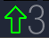

Indicator Color Coordinates

Green - Reference SDS IL-0017

Indicator Characteristics

Pixel Display in Message Center Display – Upshift_RTT (#TBD)

Audio

None.

System Accuracy

The Upshift_RTT/Downshift_RTT/Gear_Indication/EcoMode_RTT/Upshift_Eco_RTT/Downshift_Eco_RTT shall change the state of the RTT within 100msec of a state change as indicated in the state matrix reference 1.3.5.1 Subsystem Algorithm Flowchart/ State Diagram

Operation: Performance and Functional

Subsystem Algorithm Flowchart / State Diagram

- State Matrix for Upshift_RTT Flag
Operational_  Mode | Upshift_  Indicator_Cfg | EcoMode_Cfg | DIAG_  SESSION_  TIMER | DIAG_DID_  61CE, 3, 7  (Upshift  Indicator) | TrnManShif_D_IndDrv Signal | ActvDrvMde_D2_Stat Signal | Upshift_RTT | Upshift_Eco_RTT
Normal or  Crank | Enabled | Disabled | Not Active | X | Upshift_Fuel_Economy_  recommendation (0x1) | X | Active | Inactive
Normal or  Crank | Enabled | Enabled | Not Active | X | Upshift_Fuel_Economy_  recommendation (0x1) | SelDrvMde04 (0x3) | SelDrvMde05 (0x4) | Inactive | Active
 |  |  |  |  |  | ! (SelDrvMde04 (0x3) | SelDrvMde05 (0x4)) | Active | Inactive
 |  |  |  |  |  | Missing as per 1.4.1 | Active | Inactive
Normal or  Crank | Enabled | X | Not Active | X | Upshift_Performance_  Recommendation (0x2) |  Upshift_warning (fuel cut imminent and reaching rev limit) (0x3) | X | Active | Inactive
 |  |  |  |  | Missing as per 1.4.1 | X | Inactive | Inactive
Normal | Enabled | Disabled | Active | Not Received | Upshift_Fuel_Economy_  recommendation (0x1) | X | Active | Inactive
Normal | Enabled | Enabled | Active | Not Received | Upshift_Fuel_Economy_  recommendation (0x1) | SelDrvMde04 (0x3) | SelDrvMde05 (0x4) | Inactive | Active
 |  |  |  |  |  | ! (SelDrvMde04 (0x3) | SelDrvMde05 (0x4)) | Active | Inactive
 |  |  |  |  |  | Missing as per 1.4.1 | Active | Inactive
Normal | Enabled | X | Active | Not Received | Upshift_Performance_  Recommendation (0x2) |  Upshift_warning (fuel cut imminent and reaching rev limit) (0x3) | X | Active | Inactive
 |  |  |  |  | Missing as per 1.4.1 | X | Inactive | Inactive
Normal | Enabled | X | Active | ON (0x1) | X | X | Active | Inactive
All Other Cases |  |  |  |  |  |  | Inactive | Inactive
X=Don’t Care
Not Received = The state when a DIAG_SESSION_TIMER is active and the DID has not been received

- State Matrix for Downshift_RTT Flag
Operational_Mode | Down_Shift_  Indicator_Cfg | EcoMode_Cfg | TrnManShif_D_IndDrv Signal | ActvDrvMde_D2_Stat Signal | Downshift_RTT | Downshift_Eco_RTT
Normal or Crank | Enabled | Disabled | Downshift_recommendation (0x4) | X | Active | Inactive
Normal or Crank | Enabled | Enabled | Downshift_recommendation (0x4) | SelDrvMde04 (0x3) | SelDrvMde05 (0x4) | Inactive | Active
 |  |  |  | ! (SelDrvMde04 (0x3) | SelDrvMde05 (0x4)) | Active | Inactive
 |  |  |  | Missing as per 1.4.1 | Active | Inactive
Normal or Crank | Enabled | X | Missing as per 1.4.1 | X | Inactive | Inactive
All Other Cases |  |  |  |  | Inactive | Inactive
X=Don’t Care
Not Received = The state when a DIAG_SESSION_TIMER is active and the DID has not been received
- State Matrix for Gear_Indication
Operational_Mode | Target_Gear_  Indication_Cfg | TrnManShif_D_IndDrv Signal | TrnManShifGear_  D_IndDrv Signal | Gear_  Indication
Normal or Crank | Enabled | Upshift_Fuel_Economy_  recommendation (0x1) |  Upshift_Performance_  Recommendation (0x2) |  Upshift_warning (fuel cut imminent and reaching rev limit) (0x3) | Indicate gear 1 (0x1) | 2
Normal or Crank | Enabled |  | Indicate gear 2 (0x2) | 3
Normal or Crank | Enabled |  | Indicate gear 3 (0x3) | 4
Normal or Crank | Enabled |  | Indicate gear 4 (0x4) | 5
Normal or Crank | Enabled |  | Indicate gear 5 (0x5) | 6
Normal or Crank | Enabled | Downshift_recommendation (0x4) | Indicate gear 2 (0x2) | 1
Normal or Crank | Enabled | Downshift_recommendation (0x4) | Indicate gear 3 (0x3) | 2
Normal or Crank | Enabled | Downshift_recommendation (0x4) | Indicate gear 4 (0x4) | 3
Normal or Crank | Enabled | Downshift_recommendation (0x4) | Indicate gear 5 (0x5) | 4
Normal or Crank | Enabled | Downshift_recommendation (0x4) | Indicate gear 6 (0x6) | 5
Normal or Crank | Enabled | Missing as per 1.4.1 | X | Inactive
Normal or Crank | Enabled | X | Missing as per 1.4.1 | Inactive
All Other Cases |  |  |  | Inactive
X=Don’t Care
Not Received = The state when a DIAG_SESSION_TIMER is active and the DID has not been received
Note: Upshift Indicator Cfg and/or Down Shift Indicator Cfg must be Enabled for this bit to be Enabled. At the time of this release, this bit should be Disabled on vehicles with Automatic transmissions.

- State Matrix for EcoMode_RTT
Operational_Mode | Internal Cfg  for SIL/Eco | EcoMode_  Cfg | Upshift_  RTT | Upshift_  Eco_RTT | Downshift_  RTT | Downshift_  Eco_RTT | ActvDrvMde_D2  _Stat Signal | EcoMode_  RTT
Normal or  Crank | Same  location | Enabled | Inactive | Inactive | Inactive | Inactive | SelDrvMde04 (0x3) | SelDrvMde05 (0x4) | Active
Normal or  Crank | Different  location | Enabled | X | X | X | X | SelDrvMde04 (0x3) | SelDrvMde05 (0x4) | Active
All Other Cases |  |  |  |  |  |  |  | Inactive

Note: Internal Cfg determines if SIL (Upshift/Downshift) RTT’s and EcoMode_RTT use the same location. If they do not use the same location, then the EcoMode_RTT activation will be independent of the SIL state.

Note: When SDM_Cfg = 0x1 (Enabled), the EcoMode_RTT becomes part of selectable drive mode.

Figure 3 has been adopted from Selectable Drive Mode Control Function CGEA 1.3_1.0 STSS and updated to only include CAN signals relevant to B479. If the program adds SDM, then this figure will be deleted as part of the next revision.
Figure 3: Selectable Drive Mode IPC Initialization Flowchart
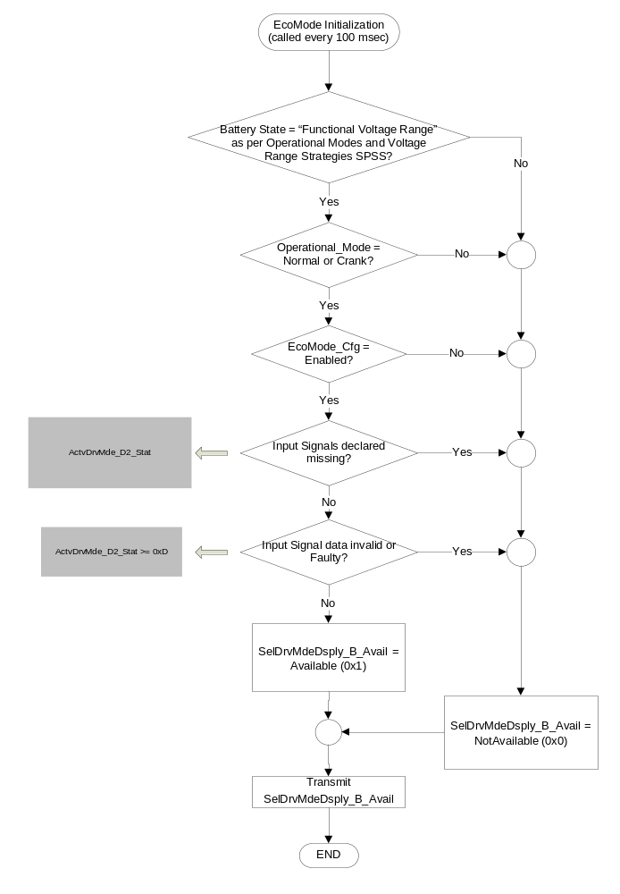

Operation Description (supports algorithm flowchart /state diagram)

- The actual RTT display operational modes are displayed in the Message Center Section of this SPSS.
- The Upshift Indicator shall be implemented in a Fixed/Dedicated RTT to ensure regulation is met.
- The Upshift_RTT, Downshift_RTT, Upshift_Eco_RTT, Downshift_Eco_RTT and EcoMode_RTT indicators are mutually exclusive and should share the same space.
- The Gear_Indication is intended only for vehicles with Manual Transmissions and requires an Active Upshift/Down Shift indication to be displayed.
- There are a possible of 31 drive modes. Each drive mode is mapped with a state of the CAN signal. However, the CAN signals from the ABS are kept generic to provide flexibility since the order of the drive modes can change from one program to another.
Defined Drive Modes:
SelDrvMde01 = Normal Mode
SelDrvMde02 = Sport Mode
SelDrvMde03 = Comfort Mode
SelDrvMde04 = Economy Mode
SelDrvMde05 = Economy Comfort Mode
SelDrvMde06 = Low Mu Mode
SelDrvMde07 = Tow Haul Mode
SelDrvMde08 = Mud/Rut Mode
SelDrvMde09 = Sand Mode
SelDrvMde10 = Rock Crawl Mode
SelDrvMde11 = Normal 2H Mode
SelDrvMde12 = Normal 4A Mode
SelDrvMde13 = Normal 4L Mode
SelDrvMde14 = not used
SelDrvMde15 = not used
SelDrvMde16 = not used
SelDrvMde17 = not used
SelDrvMde18 = not used
SelDrvMde19 = not used
SelDrvMde20 = not used
SelDrvMde21 = not used
SelDrvMde22 = not used
SelDrvMde23 = not used
SelDrvMde24 = not used
SelDrvMde25 = not used
SelDrvMde26 = not used
SelDrvMde27 = not used
SelDrvMde28 = not used
SelDrvMde29 = not used
SelDrvMde30 = not used
SelDrvMde31 = not used
Faulty = Faulty

Function Safety Classification (EMC)

B

Memory Storage

Parameter Name | Description | Value at  Battery Connect | Value at  Module Wake-up
Upshift_RTT | Used to control the state of the RTT | Inactive (0x0) | Inactive (0x0)
Downshift_RTT | Used to control the state of the RTT | Inactive (0x0) | Inactive (0x0)
Gear_Indication | Used to control the state of the Gear Indication portion of the RTT | Inactive (0x0) | Inactive (0x0)
Upshift_Indicator_Cfg | Encoded indicator of feature presence controlled via CAN at EOL at VO plant. | Use Stored Value | Use Stored Value
Down_Shift_Indicator_Cfg | Encoded indicator of feature presence controlled via CAN at EOL at VO plant. | Use Stored Value | Use Stored Value
Gear_Indication_Cfg | Encoded indicator of feature presence controlled via CAN at EOL at VO plant. | Use Stored Value | Use Stored Value
TrnManShif_D_IndDrv Signal | CAN Signal sent from the PCM | No_Indication (0x0) | Do Not Init
TrnManShifGear_D_IndDrv Signal | CAN Signal sent from the PCM | No_Indication (0x0) | Do Not Init
DIAG_DID_61CE Byte 3 Bit 7 (Upshift Indicator) | Warning Lamp “B” Status, byte 3, bit 7 (Upshift Indicator) | 0 (0x0) | 0 (0x0)
Operational_Mode | 4 state indicator for cluster operational mode | Limited | Limited, Normal or Crank
Upshift_Eco_RTT | Used to control the state of the RTT | Inactive (0x0) | Inactive (0x0)
Downshift_Eco_RTT | Used to control the state of the RTT | Inactive (0x0) | Inactive (0x0)
EcoMode_RTT | Used to control the state of the RTT | Inactive (0x0) | Inactive (0x0)
EcoMode_Cfg | Encoded indicator of feature presence controlled via CAN at EOL at VO plant. | Use Stored Value | Use Stored Value
SelDrvMdeDsply_B_Avail | Output signal from IPC to ABS providing current status of SDM display | NotAvailable  (0x0) | NotAvailable  (0x0)
ActvDrvMde_D2_Stat | Input from ABS providing the currently confirmed drive mode | Faulty (0x1F) | Do Not Init

Parameter Name | Description | Value at  Battery Connect | Value at  Module Wake-up
DIAG_SESSION_TIMER | Timer used to time-out a diagnostic session | Not Active | Not Active

Prove Out

No

Reconfigurable Telltale

Yes

Message Center Msg

See Message Center Section for displaying RTT based upon state of RTT flag.
W1863 is associated with the Upshift_Eco_RTT.
W1864 is associated with the Downshift_Eco_RTT.
W1865 is associated with the Upshift_RTT.
W1866 is associated with the Downshift_RTT.
W3390 is associated with the EcoMode_RTT.

Error Handling

Missing Message Strategy

The signals will be declared missing as per the Diagnostics section of this SPSS.

DTCs states and history will be determined as per the Diagnostics section of this SPSS.

If the Upshift_Indicator_Cfg is set to Disabled, the cluster shall never log a missing message DTC due to this feature. If the Shift_Indication_Cfg is set to Disabled, the cluster shall never log a missing message DTC due to TrnManShifGear_D_IndDrv being declared missing. If the EcoMode_Cfg is set to Disabled, the cluster shall never log a missing message DTC due to ActvDrvMde_D2_Stat being declared missing.

Diagnostics

Self Test

None

Engineering Test Mode

Reference section “Dealer / Engineering Test Mode (ETM)”.

Part II Performance

Supported Diagnostic DIDs (Service $22 and $2F)
Number | PID / CommonID Name | PID Type
61CE | Warning Lamp “B” Status, byte 3, bit 7 (Upshift Indicator) | Bit Mapped

Supported Diagnostic Trouble Codes (DTCs)
DTC | Description
C10000 | Lost communication with ECM/PCM
C12100 | Lost Communication With Anti-Lock Brake System (ABS) Control Module
C41500 | Invalid Data Received From Anti-Lock Brake System (ABS) Control Module
* If the missing signal has a related update bit, _UB, signal, then the “Invalid Data” DTC is to be logged. Otherwise, the “Lost Communication” DTC is logged.

DID DExx:
Block  Num | Block Description | Byte(s) | Bits | State: Description | "0" | "1" | Default | Comments/ Information
PACKETED BLOCKS
$xx | Option Content (B&A) | * | * | Upshift Indicator | Disabled | Enabled | 0 (Disabled) | Disabled means the feature is not available.
$xx | Option Content (B&A) | * | * | Down shift Indicator | Disabled | Enabled | 0 (Disabled) | Disabled means the feature is not available.
$xx | Option Content (B&A) | * | * | Target Gear Indication | Disabled | Enabled | 0 (Disabled) | Upshift Indicator Cfg and/or Down Shift Indicator Cfg must be Enabled for this bit to be Enabled. At the time of this release, this bit should be Disabled on vehicles with Automatic transmissions.
$xx | Option Content (B&A) | * | * | Shift Indication | Disable | Enable | 0 (Disable) | OBSOLETE
$xx | Option Content (B&A) | * | * | EcoMode | Disable | Enable | 0 (Disable) | Disabled means the function is not present in the vehicle.
 | *Byte and bit location to be identified in Part II Specification for this cluster

Reference Specification

IS-0001 WARNINGS/INDICATORS/DISPLAYS PROVEOUT
IS-0046 INSTRUMENTATION MATERIAL RESISTANCE TO CLEANING
IS-0052 OPERATING VOLTAGES - FUNCTIONAL/PERFORMANCE
IS-0069 FUNCTIONAL IMPORTANCE CLASS
IS-0324 WINDSHIELD & OTHER REFLECTIONS
IS-0327 WARNING INDICATOR EVALUATION
IS-0329 FLICKERING OF LAMPS
IS-0379 NORTH AMERICAN WARNINGS AND INDICATORS STRATEGY

IL-0017 TELLTALE AND INTERIOR ILLUMINATION COLOR
IL-0021 CRAFTSMANSHIP - DISPLAYS
IL-0023 CLARITY/LEGIBILITY/READABILITY
IL-0025 INTERIOR ILLUMINATION INTENSITY
IL -0027 VISUAL CONTRAST
IL -0043 OPERATIONAL ENVIRONMENT FUNCTIONALITY
IL -0045 COLOR
IL -0047 TELLTALE; INDICATOR AND DISPLAY LIGHT INTENSITY
IL -0048 ILLUMINATION ACCEPTABILITY

03-0661 PLACEMENT: CONTROL AND DISPLAY LOCATIONS
03-0662 PLACEMENT: LOGICAL GROUPING FUNCTION AND USAGE
03-0664 PLACEMENT: DOWN VISION TO COMPONENTS WITH HIGH VISUAL DEMAND
03-0665 PLACEMENT: EXPECTED LOCATIONS OF CONTROLS AND DISPLAYS VDS
03-0670 INTERIOR VISIBILITY
03-0671 INTERIOR VISIBILITY: REFLECTIONS FROM COMPONENTS & SURFACES
03-0672 INTERIOR VISIBILITY: REFLECTIONS IN DISPLAYS
03-0673 INTERIOR VISIBILITY: VISUAL OBSCURATIONS
03-0674 INTERIOR VISIBILITY: ILLUMINATION CONTROLS / DISPLAYS
03-0675 INTERIOR VISIBILITY: VEILING GLARE
03-0677 INTERIOR VISIBILITY: SUNLIGHT WASHOUT
03-0681 IDENTIFICATION: CHARACTER AND SYMBOL SIZE
03-0682 IDENTIFICATION: LEGIBILITY
03-0685 IDENTIFICATION: SYMBOLS, ABBREV FOR CONTROL
03-0721 LOGIC OF OPERATION: OPERATIONAL STEREOTYPES
03-0722 LOGIC OF OPERATION: INTERPRETATION
03-0723 LOGIC OF OPERATION: USE OF SYSTEMS WITH VISUAL DISPLAYS

Revision History

SPSS Module Revision History
Revision Level | Name | Change Description | Date
1.0 | V. Patel | Updated for Upshift telltale for CGEA1.3 based on FNA Upshift Telltale STSS ver 3.0. Changed STSS title to reflect CGEA1.3 implementation.  Section 1.1- Changed to CGEA based CAN input signal.  - Updated context diagram to include DID DE00 to read Transmission type as input instead of the old “TRANS_TYPE” CAN input. Updated to GGDS based diag DIDs and CGEA based CAN input signal.  Table 1.0 – Updated to CGEA based input signal  Section1.3.5.1 - Updated State Matrix Table to reflect CGEA based input and GGDS based diag inputs  Section 1.3.5.4 - Update Memory Storage table to reflect CGEA and GGDS based inputs.  Section 1.4.1 - Rewritten. Deleted references of specific missing message flags and timer.added new PID #  Updated DTC table to reflect GGDS based diagnostics.  Added table to denote DID DE00 | 6/30/2010
2.0 | JBlatchf | Upshift Indicator is becoming a regulatory requirement in EU countries. Intent of this change is to add Upshift Indicator specific configuration so the feature can be enabled where required in markets per regulation or to meet CAFÉ and disabled in markets where not required to prevent TGW. Color of indicator also changed from Yellow to Green to align with FoE.  1.1: Changed Config to enabled/disabled. Changed signal value to turn on telltale from 0x3 to 0x1. Direction per 6/6/2012 email from Jennifer Fazio of powertrain.  1.2.1: Changed Config  1.3.3.1.2: Changed indicator color to green.  Table 1.1: Changed Cfg. Changed signal value to turn Upshift_Telltale ON.  1.3.5.4: Modified Cfg  1.3.5.7: Added W# for Upshift Indicator RTT  1.4.1: Changed Cfg  1.5.3: Changed DID DE00 table. | 6/22/12
3.0 | jgregoir | This STSS has been renamed to include the Downshift functionality.  Downshift indicator is being added for NVH reasons (avoid driving in too high gear, which is leading to lugging boom in low RPM’s). The downshift indication is only displayed in vehicles with a manual transmission.  Downshift can share a common display space with upshift RTT.  Section 1.1 – Add text for Downshift RTT and Gear Indication.  Figure 1 – Add Transmission_Type_Cfg, Shift_Indication_Cfg, and TrnManShifGear_D_IndDrv CAN signal inputs. Add Downshift_RTT and Gear_Indication Outputs  Table 1.1 – Added for TrnManShifGear_D_IndDrv CAN signal.  Section 1.2.3 – Added Downshift_RTT and Gear_Indication Outputs  Section 1.3.1 – Added Downshift_RTT and Gear_Indication  Section 1.3.3.1.1 – Added graphics  Section 1.3.4 – Added Downshift_RTT and Gear_Indication  Table 1.1 (Now Table 1.2) – Update to add Transmission_Type_Cfg, Shift_Indication_Cfg, and TrnManShifGear_D_IndDrv CAN signal inputs. Added Downshift_RTT and Gear_Indication Outputs  Section 1.3.5.2 – Added description.  Section 1.3.5.4 – Added Transmission_Type_Cfg, Shift_Indication_Cfg, and TrnManShifGear_D_IndDrv CAN signal inputs. Add Downshift_RTT and Gear_Indication Outputs  Section 1.4.1 – Added TrnManShifGear_D_IndDrv  Section 1.5.3 – Add Shift Indication Cfg and Transmission Type Cfg. | 6/25/2013
4.0 | jgregoir | Changes highlighted in Yellow.  Request from Tainã Silva to have Down Shift RTT independent of Gear Indication for Indian market. Shift_Indication_Cfg configuration bit will be obsoleted. Create two new cfg bits: Down_Shift_Indicator_Cfg and Target_Gear_Indication_Cfg.  Section 1.1 – Update description.  Section 1.2.2 – Add cfg bits.  Figure 1 – Delete Shift_Indication_Cfg and Transmission_Type_Cfg. Add Down_Shift_Indicator_Cfg and Target_Gear_Indication_Cfg.  Table 1.2 – Table has been split in to three separate tables for Upshift RTT, Down Shift RTT, and Gear Indication. Delete Shift_Indication_Cfg and Transmission_Type_Cfg. Add Down_Shift_Indicator_Cfg and Target_Gear_Indication_Cfg.  Table 1.3 – New table for Down Shift RTT. Uses new Down_Shift_Indicator_Cfg.  Table 1.4 – New table for Gear Indication. Uses new Target_Gear_Indication_Cfg.  Section 1.3.5.2 – Update bullet points.  Section 1.3.5.4 – Delete Shift_Indication_Cfg and Transmission_Type_Cfg. Add Down_Shift_Indicator_Cfg and Target_Gear_Indication_Cfg.  Section 1.5.3 – Delete Shift_Indication_Cfg and Transmission_Type_Cfg. Add Down_Shift_Indicator_Cfg and Target_Gear_Indication_Cfg. | 6/17/2014
5.0 | jgregoir | Changes highlighted in Blue.  Nick Crisp is the feature owner for EcoMode.  Add ECO Mode function to Upshift and Downshift RTT to make the shift indicator arrow more visible when EcoMode is active. Add EcoMode RTT.  Section 1.1 – Add description  Figure 1 – Add EcoMode_Cfg, StopStrtDrvMde_D_Indic, EcoMode_RTT, Upshift_Eco_RTT, and Downshift_Eco_RTT.  Section 1.2.2 – Add EcoMode_Cfg  Table 1.2 – New table for StopStrtDrvMde_D_Indic CAN Signal.  Section 1.2.3 – Add EcoMode_RTT, Upshift_Eco_RTT, and Downshift_Eco_RTT.  Section 1.3.1 – Add EcoMode_RTT, Upshift_Eco_RTT, and Downshift_Eco_RTT.  Section 1.3.3.1.1 – Update and add graphics for RTT’s.  Section 1.3.4 – Add EcoMode_RTT, Upshift_Eco_RTT, and Downshift_Eco_RTT.  Table 1.3 – Update for Upshift_Eco_RTT  Table 1.4 – Update for Downshift_Eco_RTT  Table 1.6 – New table for EcoMode_RTT  Section 1.3.5.2 – Add description for Upshift_Eco_RTT, Downshift_Eco_RTT, and EcoMode_RTT.  Section 1.3.5.4 – Add EcoMode_Cfg, EcoMode_RTT, Upshift_Eco_RTT, and Downshift_Eco_RTT.  Section 1.3.5.7 – Add warring numbers for new RTT’s  Section 1.4.1 – Add StopStrtDrvMde_D_Indic and EcoMode_Cfg.  Section 1.5.3 – Add EcoMode_Cfg | 2/6/2015
5.1 | jgregoir | Changes highlighted in Green.  Add missing condition to table.  Page 6 Table 1.6 – Add Downshift_RTT column. | 3/18/2015

6.0 B479 Specific | jgregoir | This release is specific to the B479 program.  The cluster needs to subscribe to the Eco Mode state signal ActvDrvMde_D_Stat for the B479 SDM-CAN based implementation. This new signal will take the place of the StopStrtDrvMde_D_Indic CAN signal.  Page 1 Figure 1 – Replace StopStrtDrvMde_D_Indic CAN signal with ActvDrvMde_D_Stat CAN signal.  Page 2 Table 1.2 – Replace StopStrtDrvMde_D_Indic CAN signal with ActvDrvMde_D_Stat CAN signal.  Page 5 Table 1.3 – Replace StopStrtDrvMde_D_Indic CAN signal with ActvDrvMde_D_Stat CAN signal.  Page 5 Table 1.4 – Replace StopStrtDrvMde_D_Indic CAN signal with ActvDrvMde_D_Stat CAN signal.  Page 6 Table 1.6 – Replace StopStrtDrvMde_D_Indic CAN signal with ActvDrvMde_D_Stat CAN signal.  Page 7 Section 1.3.5.4 – Add ActvDrvMde_D_Stat CAN signal | 7/15/2015
6.1 B479 Specific | jgregoir | Changes in Orange.  This release is specific to the B479 program.  Page 1 Section 1.1 – Add note that this STSS is specific to the B479 program. Updated description of EcoMode behavior.  Page 1 Figure 1 – Update ActvDrvMde_D_Stat to ActvDrvMde_D2_Stat. Add SelDrvMdeDsply_B_Avail.  Page 2 Table 1.2 – Update ActvDrvMde_D_Stat to ActvDrvMde_D2_Stat. Page 3 Table 1.3 – New table added for SelDrvMdeDsply_B_Avail.  Page 5 Table 1.4 – Update logic for TrnManShif_D_IndDrv and ActvDrvMde_D2_Stat CAN Signals.  Page 5 Table 1.5 – Update logic for ActvDrvMde_D2_Stat CAN Signal.  Page 6 Table 1.7 – Update logic for ActvDrvMde_D2_Stat CAN Signal and add internal cfg bit for SIL/EcoMode RTT location.  Page 7 Figure 3 – Added figure for SelDrvMdeDsply_B_Avail.  Page 8 Section 1.3.5.2 – Corrected typo and added description of SelDrvMdeDsply_B_Avail state encoding.  Page 9 Section 1.3.5.4 – Add ActvDrvMde_D2_Stat and SelDrvMdeDsply_B_Avail.  Page 9 Section 1.4.1 – Update ActvDrvMde_D_Stat to ActvDrvMde_D2_Stat.  Page 10 Section 1.5.3 – Add DTC’s. | 1/20/2016

